**To know which customer is spending more money in total from Highest to Lowest**

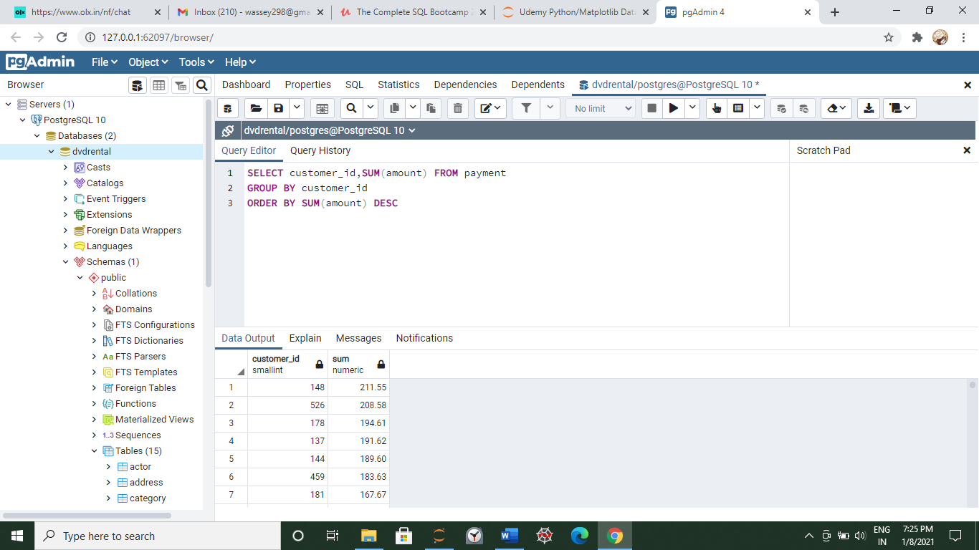

**Now use Count to know how many Transactions are occurring**

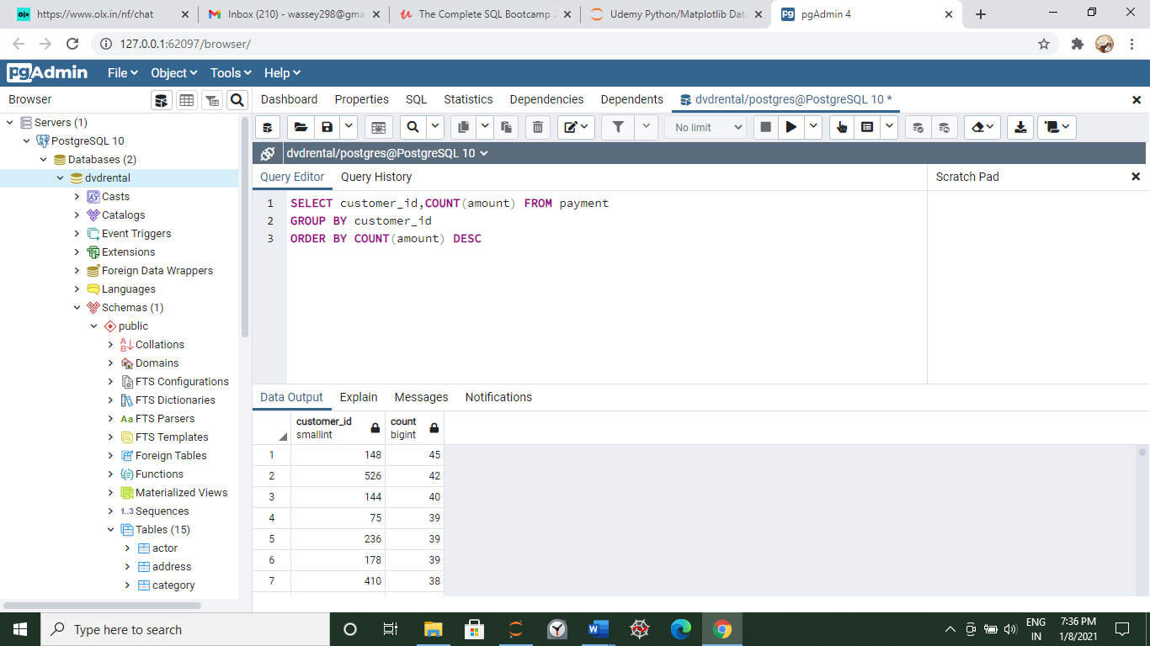

**Grouping by Staff Id and customer id to see amount**

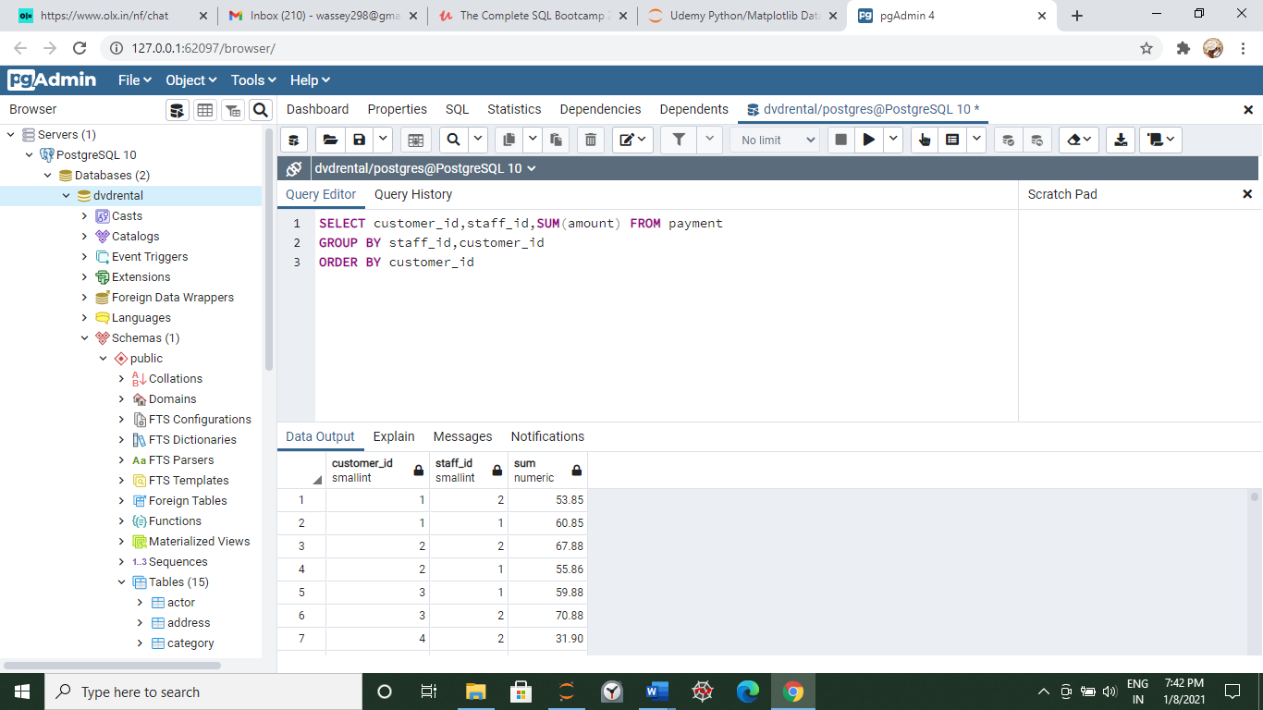

**How much sales amount we are making each day: Here We are using DATE to extract date from time-stamp**

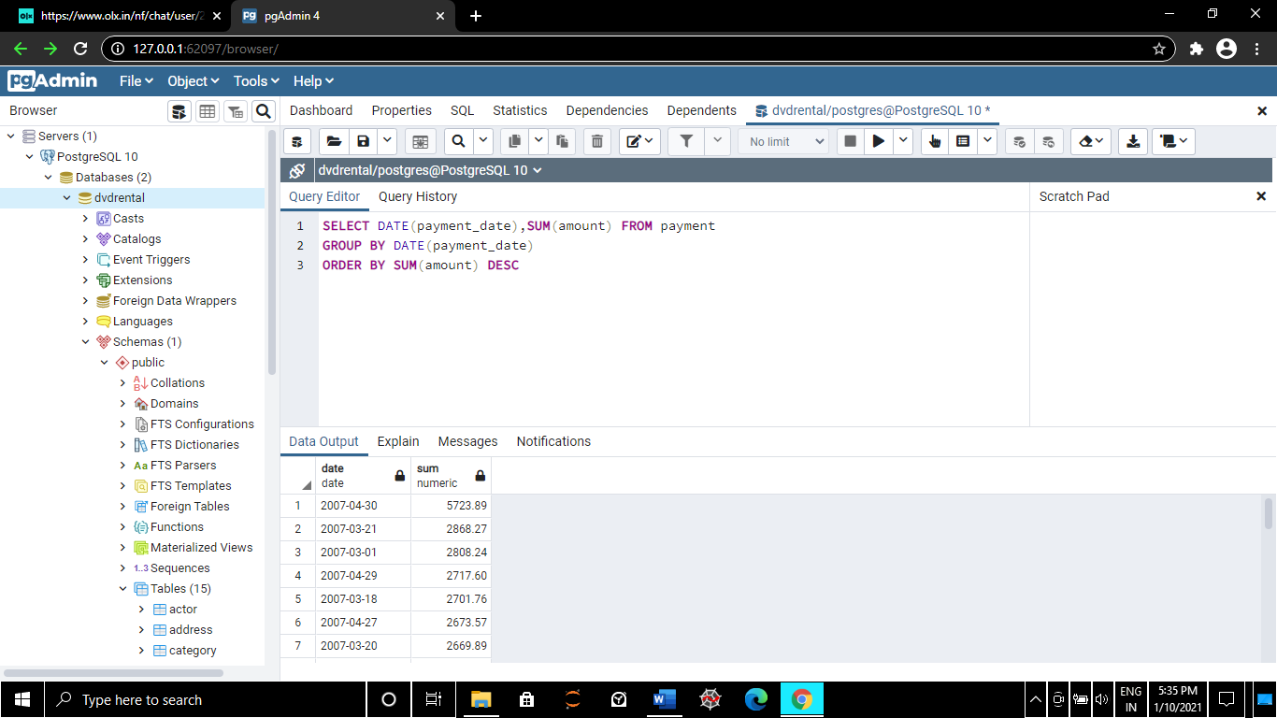

**How many payments did each staff member handle and who gets the bonus?**

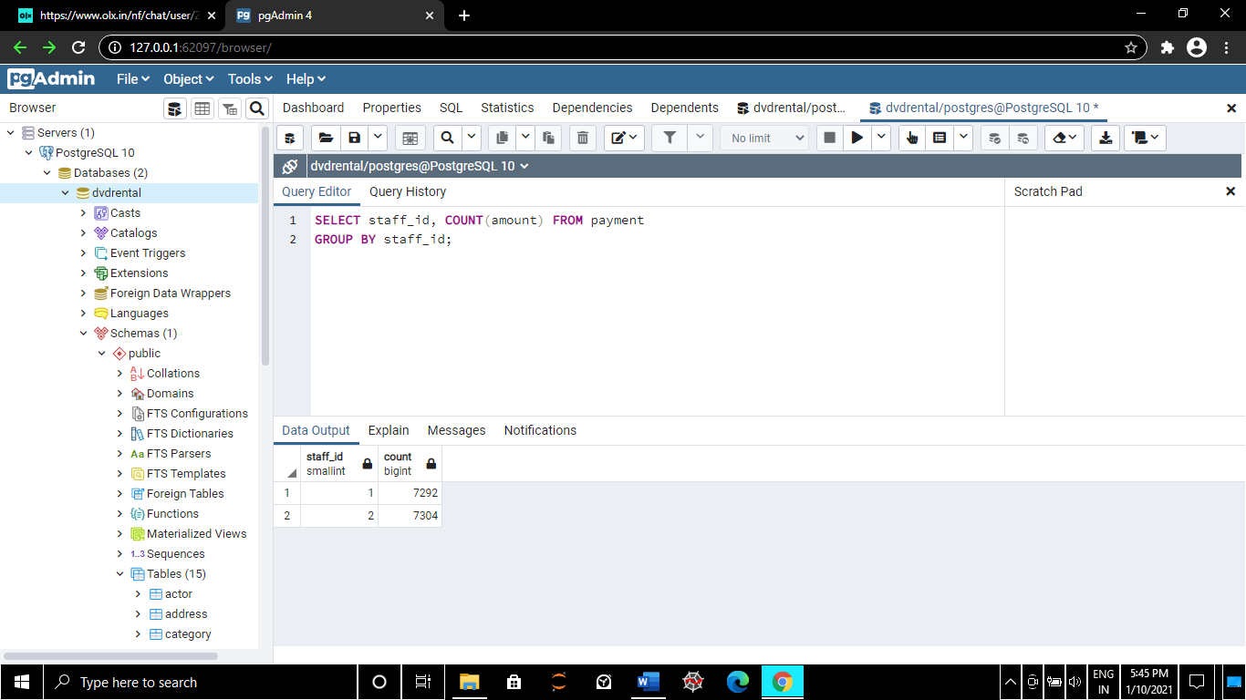

**What is the avg replacement cost per MPAA rating?**

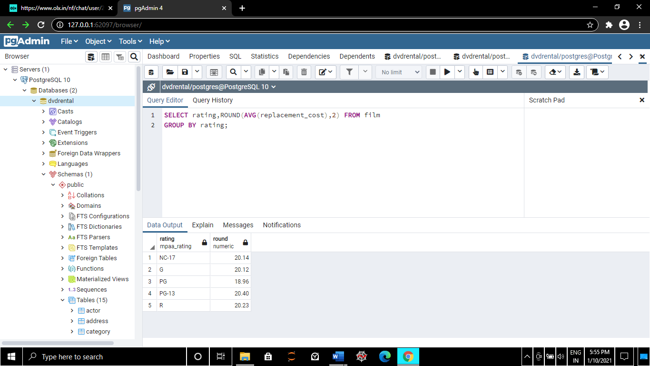

**What Are the customer ids of the top 5 customers by total spend**

